**15B17CI371 – Data Structures Lab**

**ODD 2024**

**Week 0-LAB B**

**Practice Lab**

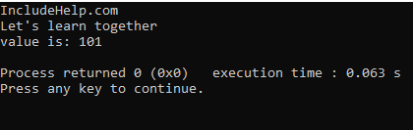

Yes, this code can serve as a basic skeleton for more complex problems. While the provided code is basic, its structure provides a solid foundation for creating more complex classes and programs. It demonstrates fundamental concepts in C++ that can be built upon for a variety of applications.

#include <iostream>

using namespace std;

class naturalnumber {

public:

int value;

naturalnumber(int v) : value(v) {}

naturalnumber operator+(const naturalnumber& other) {

return naturalnumber(value + other.value);

}

};

class complex {

public:

double real, imag;

complex(double r = 0, double i = 0) : real(r), imag(i) {}

complex operator+(const complex& other) {

return complex(real + other.real, imag + other.imag);

}

void display() const {

cout << real << " + " << imag << "i" << endl;

}

};

class matrix {

public:

int rows, cols;

int** data;

matrix(int r, int c) : rows(r), cols(c) {

data = new int*[rows];

for (int i = 0; i < rows; ++i) {

data[i] = new int[cols]();

}

}

void input() {

cout << "enter elements of the matrix (" << rows << "x" << cols << "):" << endl;

for (int i = 0; i < rows; ++i) {

for (int j = 0; j < cols; ++j) {

cin >> data[i][j];

}

}

}

matrix operator+(const matrix& other) {

if (rows != other.rows || cols != other.cols) {

cerr << "matrices dimensions do not match!" << endl;

exit(EXIT_FAILURE);

}

matrix result(rows, cols);

for (int i = 0; i < rows; ++i) {

for (int j = 0; j < cols; ++j) {

result.data[i][j] = data[i][j] + other.data[i][j];

}

}

return result;

}

void display() const {

for (int i = 0; i < rows; ++i) {

for (int j = 0; j < cols; ++j) {

cout << data[i][j] << " ";

}

cout << endl;

}

}

~matrix() {

for (int i = 0; i < rows; ++i) {

delete[] data[i];

}

delete[] data;

}

};

int main() {

naturalnumber num1(10), num2(20);

naturalnumber sum = num1 + num2;

cout << "sum of natural numbers: " << sum.value << endl;

complex c1(3.4, 5.6), c2(1.2, 4.3);

complex csum = c1 + c2;

cout << "sum of complex numbers: ";

csum.display();

int rows, cols;

cout << "enter the number of rows and columns for matrices: ";

cin >> rows >> cols;

matrix m1(rows, cols), m2(rows, cols);

m1.input();

m2.input();

matrix msum = m1 + m2;

cout << "sum of matrices:" << endl;

msum.display();

return 0;

}

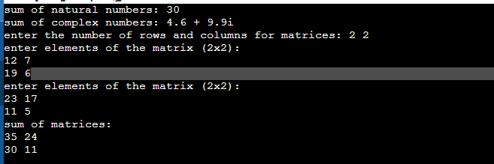

**3)**

#include<iostream>

using namespace std;

class vendor

{

    public:

    string name;

    int liscnumber;

    int lanq;

    int keyboard_sp;

    void inputdetails()

    {

        cout<<"enter the name of the vendor : ";

        cin>>name;

        cout<<"enter the License number of the vendor : ";

        cin>>liscnumber;

        cout<<"enter the quantity of LAN cables available : ";

        cin>>lanq;

        cout<<"enter the selling price of the keyboard : ";

        cin>>keyboard_sp;

    }

    void printdetails()

    {

        cout<<"\n\nPrinting Details :\n\n";

        cout<<"name of the vendor : "<<name<<"\n";

        cout<<"License number of the vendor : "<<liscnumber<<"\n";

        cout<<"quantity of LAN cables available : "<<lanq<<"\n";

        cout<<"selling price of the keyboard : "<<keyboard_sp<<"\n";

    }

    void compareven(vendor v1,vendor v2)

    {

        if(v1.keyboard_sp>v2.keyboard_sp)

        {

            cout<<"Vendor "<<[v2.name](http://v2.name/)<<" has lower selling price of the keyboard \n";

        }

        else

        {

            cout<<"Vendor "<<[v1.name](http://v1.name/)<<" has lower selling price of the keyboard \n";

        }

        if(v1.lanq>v2.lanq)

        {

            cout<<"Vendor "<<[v1.name](http://v1.name/)<<" has more LAN cables\n";

        }

        else

        {

            cout<<"Vendor "<<[v2.name](http://v2.name/)<<" has more LAN cables\n";

        }

    }

    void findv(vendor p[],int countr)

    {

        int maxlan= p[0].lanq;

        int index = 0;

        for(int i=0; i<countr; i++)

        {

            if(p[i].lanq>maxlan)

            {

                maxlan=p[i].lanq;

                index=i;

            }

        }

        cout<<"the vendor with maximum quantity of LAN cables is : "<<p[index].name<<"\n\n";

    }

    void findprice(vendor k[],int countr)

    {

        int minprice = k[0].keyboard_sp;

        int index = 0;

        for(int i=0; i<countr; i++)

        {

            if(k[i].keyboard_sp<minprice)

            {

                minprice=k[i].keyboard_sp;

                index=i;

            }

        }

        cout<<"the vendor with maximum quantity of LAN cables is : "<<k[index].name<<"\n\n";

    }

};

int main()

{

    int countr;

    cout<<"enter the number of counter : ";

    cin>>countr;

    vendor * arr = new vendor[countr];

    for(int i=0;i<countr;i++)

    {

        arr[i].inputdetails();

    }

    for(int i=0;i<countr;i++)

    {

        arr[i].printdetails();

    }

    int index1,index2;

    cout<<"enter the indexes of the vendors to be compared : ";

    cin>>index1>>index2;

    arr[0].compareven(arr[index1],arr[index2]);

    arr[0].findprice(arr,countr);

    arr[0].findv(arr,countr);

    return 0;

}

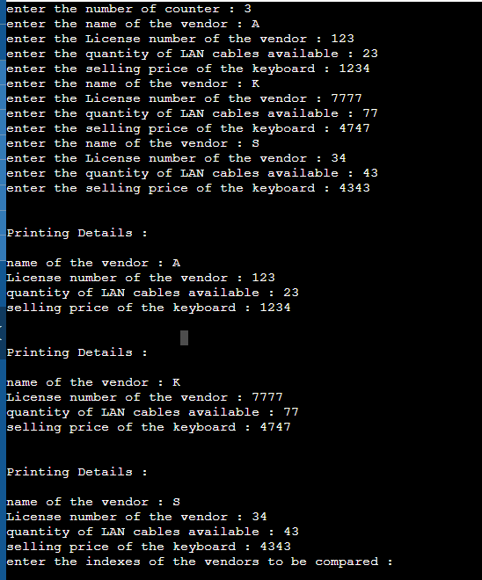

**4)**

a.

#include<iostream>

using namespace std;

class Test {

public:

int x;

};

int main()

{

Test t;

cout << t.x;

return 0;

}

Output

Error: The variable ‘x’ is private within the context and cannot be accessed outside the class.

b. #include<iostream>

using namespace std;

class Empty {};

int main()

{

cout << sizeof(Empty);

return 0;

}

Output:1

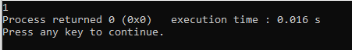

c.

#include<iostream>

using namespace std;

class Test

{

static int x;

int *ptr;

int y;

};

int main()

{

Test t;

cout << sizeof(t)<<"\n";

cout << sizeof(Test *);

}

Output:

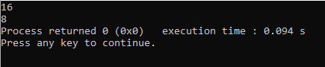

d.

#include <iostream>

class Test

{

public:

int i;

void get();

};

void Test::get()

{

std::cout << "Enter the value of i:"<<"\n";

std::cin>>i;

}

Test t;

int main()

{

Test t; // local object

t.get();

std::cout <<"value of i in local t:"<<t.i<<"\n";

::t.get();

std::cout << "value of i in global t:"<<::t.i<<"\n";

return 0;

}

Output:

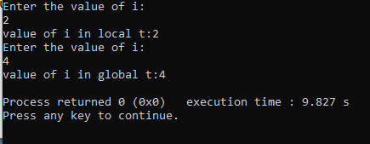

e.

#include <iostream>

#include <string>

using namespace std;

class Student {

private:

int rollNo;

string stdName;

float perc;

public:

void setValue()

{

rollNo = 0;

stdName = "None";

perc = 0.0f;

}

void printValue()

{

cout << "Student's Roll No.: " << rollNo <<

"\n";

cout << "Student's Name: " << stdName <<

"\n";

cout << "Student's Percentage: " << perc <<

"\n";

}

};

int main()

{

Student std;

std.setValue();

std.printValue();

return 0;

}

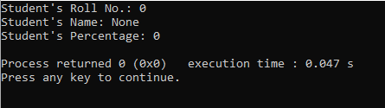

f.

#include <iostream>

using namespace std;

class Person {

};

int main() {

Person per;

cout << "size of per: " << sizeof(per) << endl;

return 0;

}

